  - Data: Element, Variable,Quantitative variable, Qualitative variable
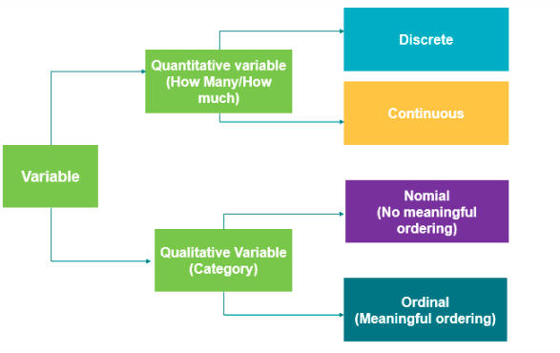
  - Data Sources: Existing sources
Experimental studies:能控制
Observational studies：控制不了
Response Variable：感兴趣的量
Factor：其它变量

  - Population and sample
Census
Two types of statistics:Descriptive Statistics and Inferential Statistics.
  - Cell phone cost：Random Sampling method
Marketing research case：Mall intercept method
Coffee temperature: In statistical control
Car Mileage: In statistical control.

